27. Strain Analysis with the Projection Method (Panozzo Method)

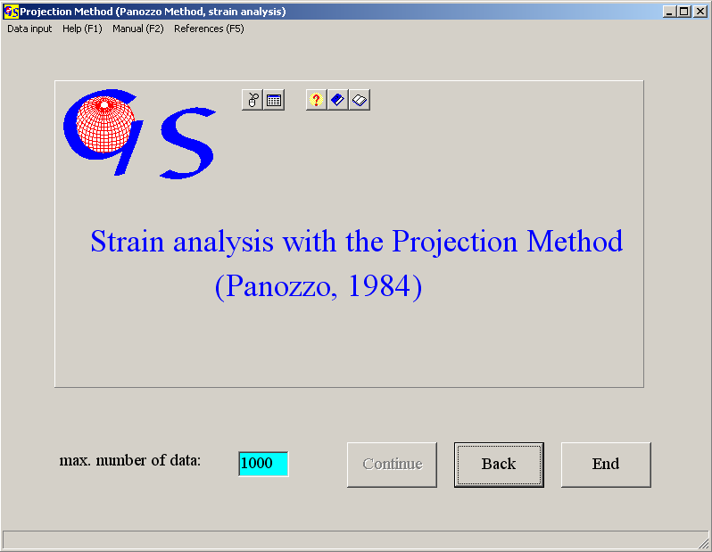
Fig. 1

This program (Fig. 1) finds the shape of a strain ellipse from particle boundaries. In the image of a grain fabric (thin section or rock surface) the grain boundaries are digitised as closed polygons. These polygons are rotated through 180°. During this rotation the polygon lines are projected on a reference line. The sum of the sums of the lengths of these projections (Σp[α]) are calculated for each increment of angle (Panozzo, 1984). ΣP[α]_{max} is the long axis of the summarised strain ellipse. The angle Θ between ΣP[α]_{max} and the reference line is the dip of the llipse (Fig. 2) The ratio ΣP[α]_{max} / ΣP[α]_{min} is the ellipticity (R) of the fabric die Elliptizität (R).
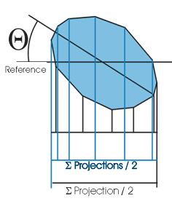Fig. 2

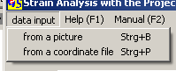
Fig. 3

Data input can be done from an image or from a file that contains the coordinates of polygon edges (Fig. 3).
Import of an image is the same as in program 26.

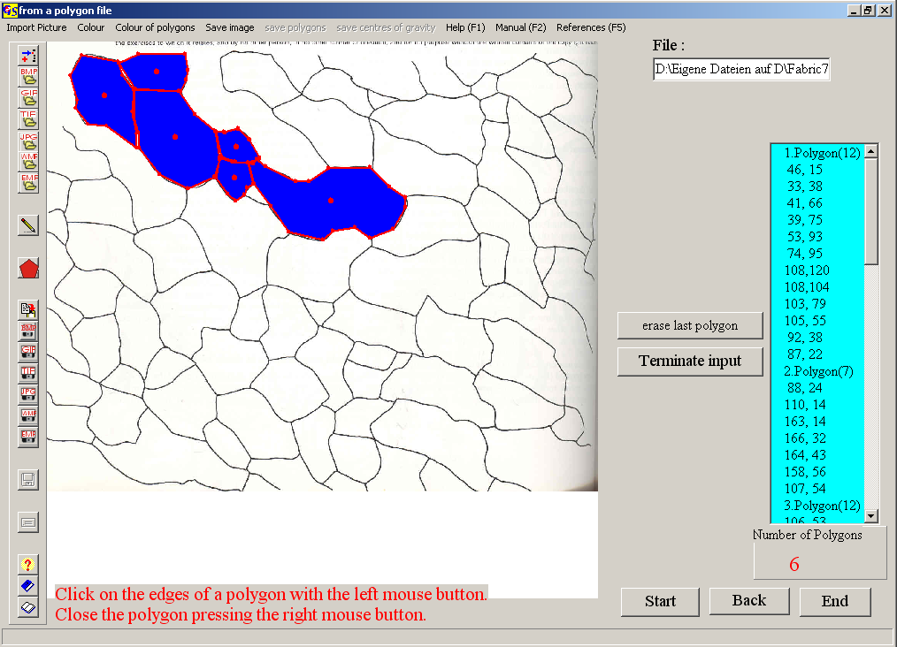
Fig. 4

Fig. 4 shows the grain boundaries in the example of Ramsay & Huber (1987). The digitising must be in the same direction (clockwise, or anticlockwise) for the whole image. With the left mouse button you click on all edge points of a polygon. The polygon is closed with the right mouse button. Colours for gthe lines and for filling are chosen in the menus "Colour" and "colour of polygons". Digitisation is terminated with the button "Terminate input". The button "plot" brings you to the graphic plot (Fig. 5).

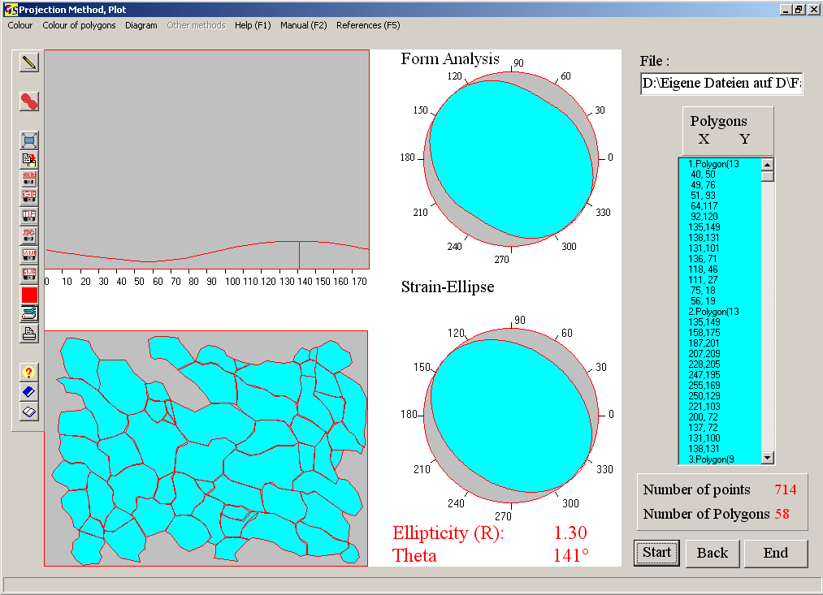
Fig. 5

The data are listed in the table on the right side. The image in the lower left corner shows the digitised polygons. In the left upper corner the normatised sums (Σp[α]) of the projected polygon lines are plotted vs. the rotation angle α. The maximum is marked by a vertical line. The diagram 'Form-Analysis' is a rose diagram of all Σp[α] dar. The 'Strain-Ellipse' is calculated from R and Θ.

